|  |
| --- |
| Home Menu |

Site 1 Freezers storyboard

Link: [Freezers – MTC Fac](https://mtcfactoryoutlet.com/product-category/appliances/freezers/)

|  |
| --- |
| [Appliances](https://mtcfactoryoutlet.com/product-category/appliances/freezers/) |

[tory Outlet](https://mtcfactoryoutlet.com/product-category/appliances/freezers/)

|  |
| --- |
| Small Appliances |

|  |
| --- |
| Audio |

|  |
| --- |
| Laundry |

|  |
| --- |
| Freezers |

|  |
| --- |
| Heating, Cooling air treatment |

|  |
| --- |
| Speakers |

|  |
| --- |
| Headphones |

|  |
| --- |
| Air Conditioners |

Site 2 Irving Ship Building

Link: [Irving Shipbuilding: Home](https://www.irvingshipbuilding.com/)

|  |
| --- |
| Home |

|  |
| --- |
| Services |

|  |
| --- |
| Facilities |

|  |
| --- |
| Markets |

|  |
| --- |
| Shipbuilding |

|  |
| --- |
| Ship Repair |

|  |
| --- |
| Facilities home |

|  |
| --- |
| Halifax Shipyard |

|  |
| --- |
| Market’s home |

|  |
| --- |
| Commercial |

Site 1 storyboard

Link: <https://mtcfactoryoutlet.com>

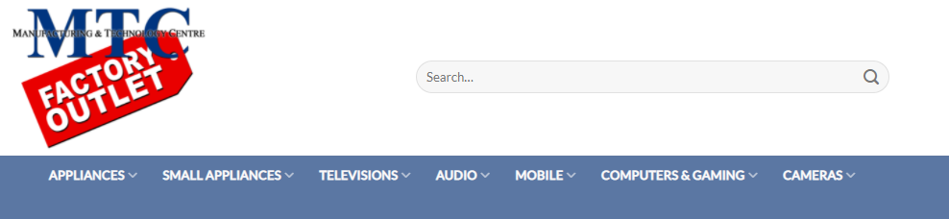

|  |
| --- |
| This is the home menu showing you things like appliances and small appliances. |

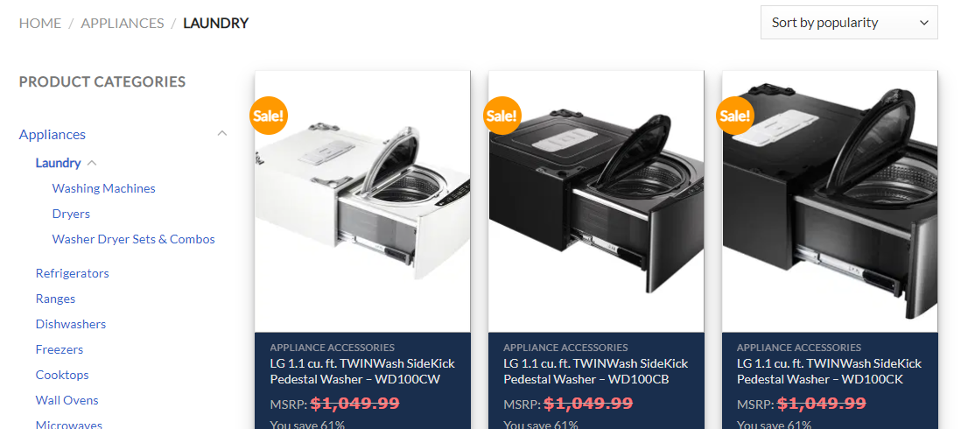

|  |
| --- |
| This is the laundry section that you can get too by hovering over appliances and clicking laundry |

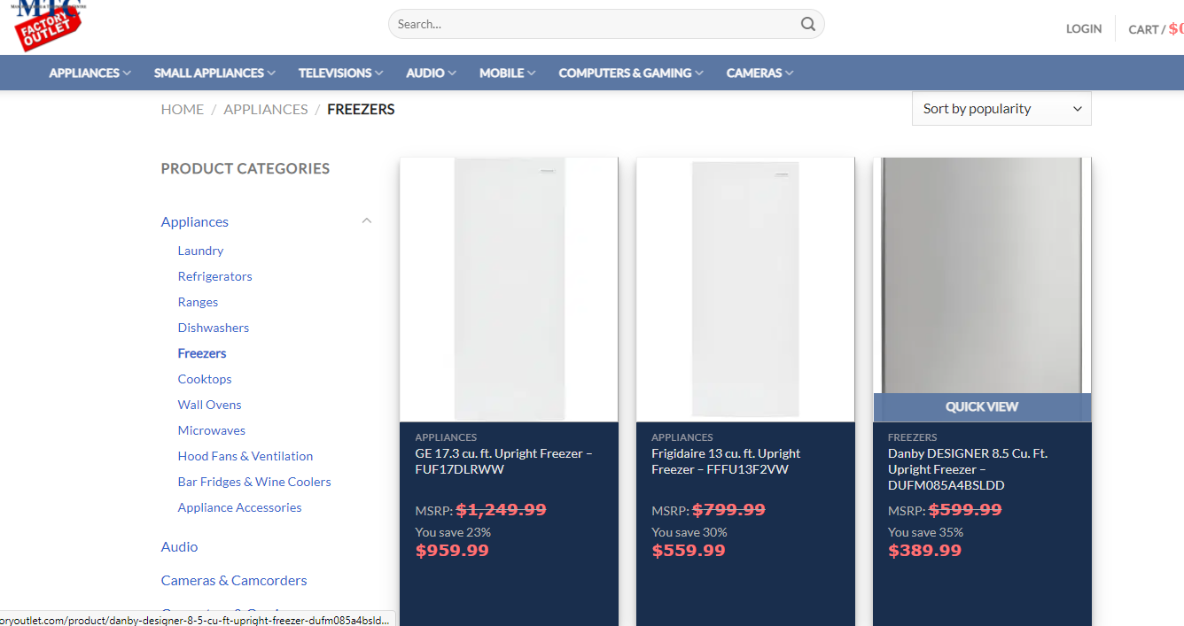

|  |
| --- |
| This is the Freezers section where you can buy a freezer you get on this by hovering over appliances again and click on freezers |

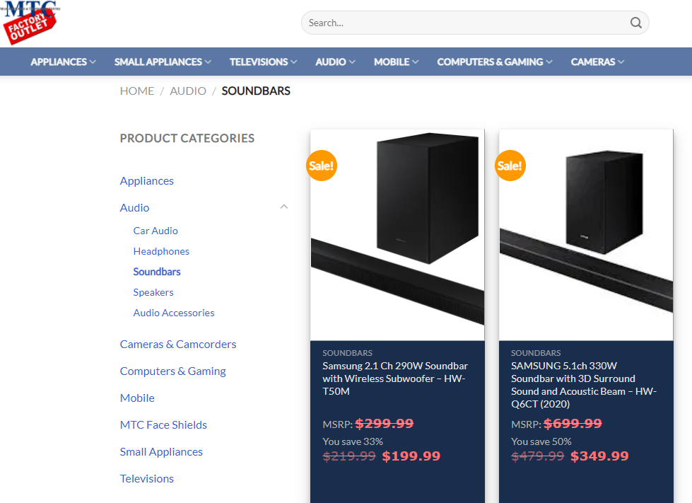

|  |
| --- |
| This is the soundbars section you get here by hovering over audio and clicking on soundbars |

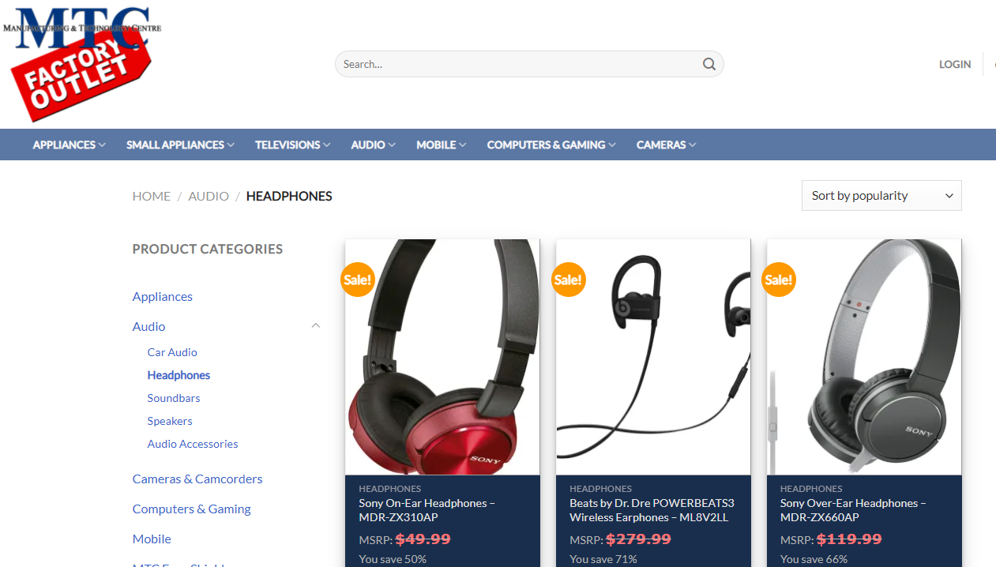

|  |
| --- |
| This is the headphones section you get on here by hovering over audio again and clicking onto the headphones link below it. |

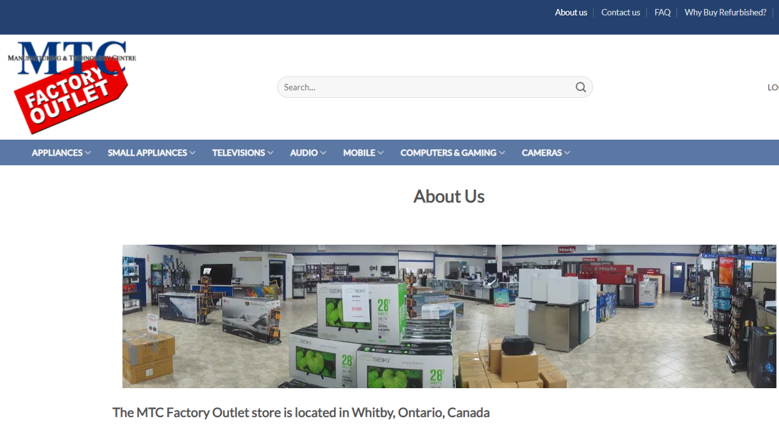

|  |
| --- |
| This is the about us page you get here from any page by looking up at the top right and clicking on about us. |

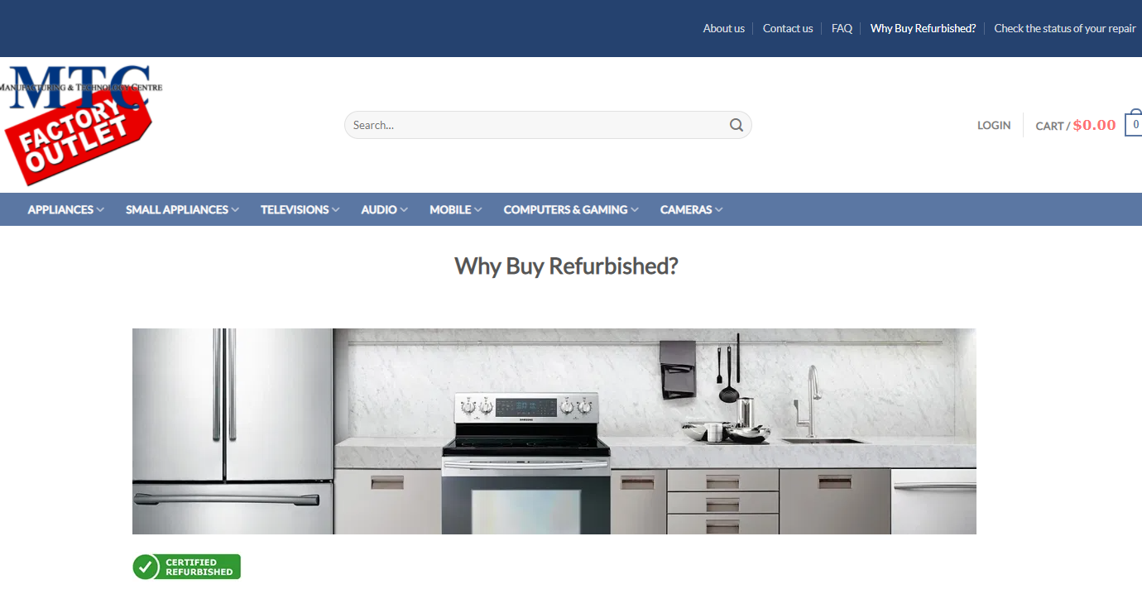

|  |
| --- |
| This is the Why Buy Refurbished? Page on this website how we get here is we click the hyperlink on the top right and once we do that we it should show Why buy refurbished close by the middle of your screen. |

Site 2 storyboard

Link: [Irving Shipbuilding: Home](https://www.irvingshipbuilding.com/)

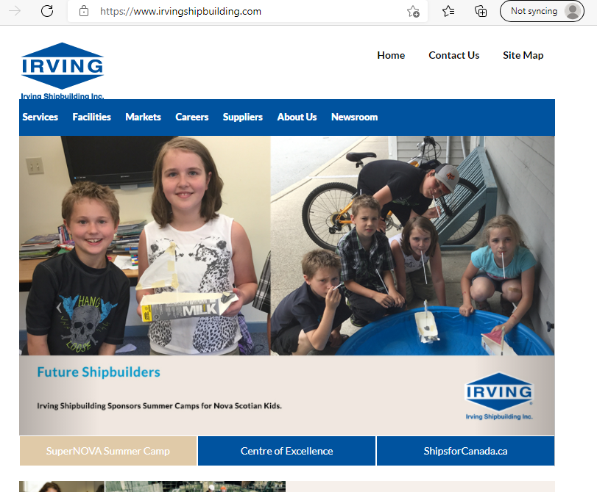

|  |
| --- |
| This is the home menu on the Irving Ship building site how we got here is we either searched up Irving ship building or we clicked on their logo on the top left or hit home on the top right |

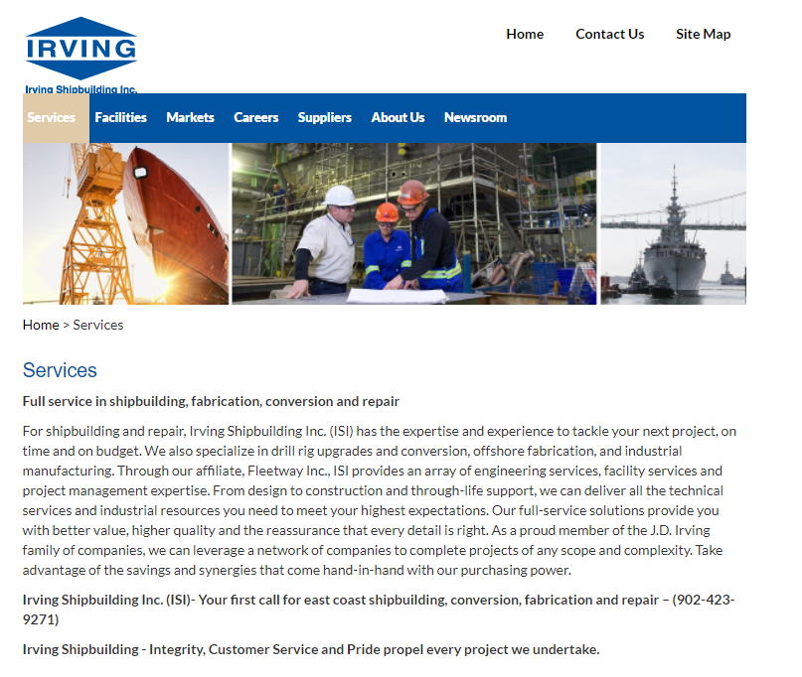

|  |
| --- |
| This is the services home page how we get here is we look below the logo we clicked on and click on services home |